Learn-2-Math
A math tutor software
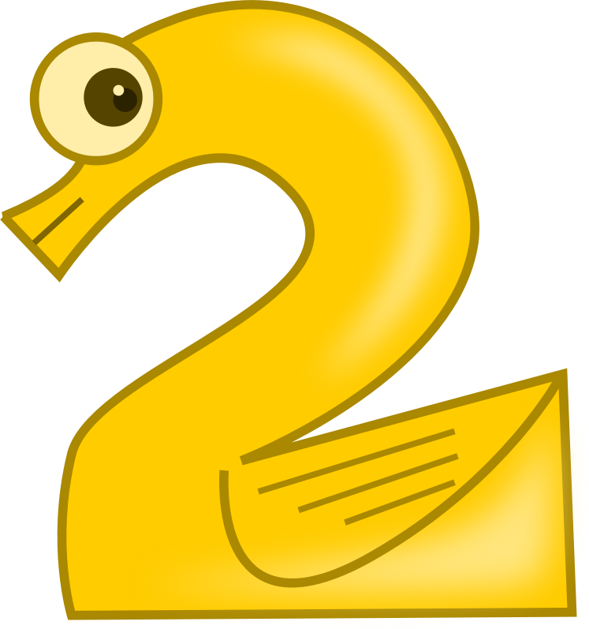

4/29/2015
Eric Sullivan
Tauseef Pirzada
Leonid Melnikov

Table of Contents
Change History 3
Purpose of Project 3
System Overview 4
Market Search 4
Feature Description 4
Requirements 6
1.1 Interface 6
Functional Requirements 6
Nonfunctional Requirement 6
1.2 Tutorials 6
Functional Requirements 6
Nonfunctional Requirement 7
1.3 Practice Test Materials 7
Functional Requirements 7
Nonfunctional Requirement 7
1.4 Account 8
Functional Requirements 8
Nonfunctional Requirement 8
1.5 Reports 8
Functional Requirements 8
Nonfunctional Requirement 8
1.6 Saving/security 8
Functional Requirements 8
Nonfunctional Requirement 9
Design 9
Test Plans 11
Appendix 12

Change History
Changes to requirements-
- Changed all file saving into the database.
- Help button only plays sound.
- Pre K tests are 6 questions long and need a 4 out of 6 to pass
Removed-
3.6.8 The .sav files name will be the username.sav.
3.6.9 .sav files will be encrypted.
3.6.10 The system shall save the progress to the users .sav file.
3.6.11 The .sav file will be in a database.
3.6.12 The .sav file will consist of three categories: progress, rewards and reports
3.6.1 The system shall use .sav files.
3.1.5 The help window shall use pictures and words.
3.1.7 The system shall open a new window to display the help information.
.sav files replaced by database
Help window replaced by voice tutorial overview
Misc
- Removed loading start screen
- Scroll bars replaced with left and right arrows for more options

Purpose of Project
The purpose of the project was to create a software that could be used by children aged 3-10 in Pre-k to Grade 4. The software is a Math tutoring software that will teach kids number sense and other important skills that they will use throughout life. Our goal was that the software be easy to learn because our clients would be mostly children, and that it helped teach the important concepts that they are supposed to learn in each grade. This is meant to be a supplement to schoolwork and helps reinforce concepts that are learned in the class room.

System Overview
  - Learn-2- Math is a GUI software.
  - It has a fixed size of 800x600 so that it can be used on a large variety of screens
  - Programmed in java to support use on different systems
  - Utilizes a database to hold questions, answers.
  - Fun Sticker Reward system for completing different modules

Market Search
There are already products that perform similar actions but our product will stand out by offering a user friendly graphical interface, fun and challenging questions for children which will promote their quest for knowledge, and an exciting theme sure to appeal to children.

Similar Products---
TouchMath- Similar software that teaches important math concepts
YouTube- Has many videos that teach concepts but lack interactive games to help reinforce the concepts learned.
Pearson enVisionmath2.0 – Similar math tutor software from Pre-k – Grade 6

Feature Description
Log In
  - Users find their name and icon that were created during user creation
    - If not found, make new account
  - Passwords are Secured on the Database with a XOR algorithm
  - Simple GUI
  - Not cluttered.
  - Made for target user which are children. Uses a soft color scheme and a theme that kids will like
  - Help provides a voiceover of how to utilize feature for younger children
Customizable Account
- Users have 4 slots to save their favorite stickers that have been earned
- Allows users to customize the rewards that they see
- Able to choose different icons for user

Grade and Module selection
Tests
- Tests are made up of fixed number of questions that are taken randomly from a pool in the Database.
- Test Questions are multiple choice.
- Test are made based on the Tutorials.
- After tests the user can review questions that they got wrong in the test.
- Tests provide rewards with stickers
- Option to print the testing screen to showcase to parents stickers and grade that they’ve earned.
Tutorials
- Each module has a tutorial that goes over the skills that should be learned
- Tutorials have a voice overview of how to use the skill for the test
Rewards
- Rewards are given to the user after completing and passing a test
- Rewards are made up of Pictures called Stickers that can be used to customize their avatar and hall of fame
- Rewards can be printed
Help
  - Voice over that helps the user understand the current page

Database
- A MySQL database holds questions and answers
- Allows the questions to be shuffled to tests will be random

Requirements

1.1 Interface

Functional Requirements
3.1.1 The interface shall be easy to use, user friendly and be understandable for children
3.1.2 Each window will have a button returning them to the previous window.
3.1.3 On all windows, the system shall have a help.
3.1.4 The help button shall give a short explanation/tutorial of the current activity.

Nonfunctional Requirement
3.1.5 The system will load png and txt files from the corresponding help folder.

1.2 Tutorials

Functional Requirements
3.2.1 The user shall take tutorials.
3.2.2 Tutorials shall use pictures to teach users.
3.2.3 Tutorials shall use words to teach users.
3.2.4 The tutorial shall teach Number sense and operation skills.

Nonfunctional Requirement
3.2.5 The Tutorials will be load the images and text file from a folder.
3.2.6 The folder will have a text file and png files.

1.3 Practice Test Materials

Functional Requirements
3.3.1 The user shall take tests after tutorials.
3.3.2 The test questions shall be multiple choice.
3.3.3 The tests shall have questions on Number sense and operation skills.
3.3.4 The user shall be able to take a harder full skill test the is made up of the skills learned in that level.
3.3.5 The system shall increase the difficulty of the tests.
3.3.6 After completing a test or math level, the system shall give the user stickers.

Nonfunctional Requirement
3.3.7 The system will create tests both randomly and from a pre-made list of questions.
3.3.8 The pre made list of questions shall be loaded from a file.
3.3.9 Any image shall be loaded from a folder
3.3.10 Pre k – k tests will have 6 questions
3.3.11 Pre k - k tests shall be passed if the user gets 3/6 correct.
3.3.12 1-2 grade tests will have 10 questions.
3.3.13 1-2 tests shall be passed if the user gets 7/10 correct.
3.3.14 3-4 grade tests will have 15 question.
3.3.15 3-4 tests shall be passed if the user gets 12/15 correct.
3.3.16 Pre k – k full skill test will have 10 questions.
3.3.17 1-2 grade full skill test will have 20 questions.
3.3.18 3-4 grade full skill test will have 30 questions.
3.3.1 Full skill tests shall be passed if the user gets 90%.

1.4 Account

Functional Requirements
3.4.1 If the user doesn't have a account, the user shall create an account.
3.4.2 the user shall enter a user name.
3.4.3 The User shall enter a password while creating an account.
3.4.4 The User shall reenter the password while creating an account.
3.4.5 The system shall prompt the user to select an account from a preexisting user list.
3.4.6 After choosing an existing account the user shall enter a password.
3.4.7 The user shall be able to log out in the main window.

Nonfunctional Requirement
3.4.8 The log-in list shall be constructed from the database.

1.5 Reports

Functional Requirements
3.5.1 The system shall give the user a report of a completed test.
3.5.2 The reports shall be printable.
3.5.3 The reports will show percentage correct
3.5.4 The reports will show pass/fail
3.5.5 The reports will show incorrect questions with the correct answer.

Nonfunctional Requirement

1.6 Saving/security

Functional Requirements
3.6.1 The system shall save progress after every test.
3.6.2 The system shall save progress after log-out.
*changed 3.6.4 The database shall have User name, Password, name of image file.

Nonfunctional Requirement
*changed 3.6.5 The user name, password and image file shall be saved into a database.
3.6.6 Passwords will be encrypted
*changed 3.6.7 The system will save new entries(with user name, password into the database if a new account is made
3.6.13The system shall be able to write and read from the database.
3.6.14 Database entries will be encrypted using a hash.
3.6.15 The hash will compared to database upon log in.

Design
Design Goal
Our goal in designing the Learn-2-Math software was to create a software for kids of grades Pre-K- Grades 4 where they could have fun exploring a jungle/animal themed math tutor software. We wanted to make sure that children could have fun while learning important math skills. The overall design of the software was meant to be easy to use because our primary clients will be little children. Some of the children won’t be able to read yet so we had to add voice over work to ensure that everyone has a chance to learn math. We decided to add animals throughout the program to entice children to pay attention to the important concepts while having some fun.

User Interface
The user interface was designed for children 3-10 years old who would have vastly different skill levels. We decided to add animals throughout the system because children like animals and would more likely pay attention. The theme, Questions, tutorials all follow a specific layout to let the children learn where buttons are and not to shuffle things around. There was a consistent color layout Questions and tutorials were designed to be intuitive and straightforward. If more time was allotted, we could do some sample questions with children and see what works for kids. We did a direct manipulation design. Almost every window was designed to have minimum buttons(around 7) to avoid distractions.

System Service
The System was designed to utilize a database in order to save questions, answers, and rewards. The general system design was a main frame holding 2 content panels. The left side was designated as a user area and the right was designated for system area. The system area has all of the modules, tests, and output. The user area holds the user information and customizable hall of fame to track progress. It also holds helpful buttons that are accessed from any page.
The database was designed to have each module as its own table, holding the questions, potential answers, correct answer, and a correct version of the question. Each module has a designated reward assigned to it. A completed table to see which sections each user has completed and what rewards they have earned. The user table holds the name, password, and the users favorite stickers that they have earned.

Test Plans
Testing Scenario
The scenario that will be tested in a user logs in, selects Pre K – K grade level, chooses any module and goes through the test to get to the reward page. We want to make sure that no errors occur between logging in, grade and module selection, question completion, and reward generation. Requirements that should be met.

1.1 Interface
3.1.3 On all windows, the system shall have a help.
3.1.4 The help button shall give a short explanation/tutorial of the current activity.

Nonfunctional Requirement
3.1.6 The system will load png and txt files from the corresponding folder

1.3 Practice Test Materials

Functional Requirements
3.3.2 The test questions shall be multiple choice.
3.3.3 The tests shall have questions on Number sense and operation skills.
3.3.6 After completing a test or math level, the system shall give the user stickers.

Nonfunctional Requirement
3.3.7 The system will create tests both randomly and from a pre-made list of questions.
3.3.8 The pre made list of questions shall be loaded from a file.
3.3.9 Any image shall be loaded from a folder
3.3.10 Pre k – k tests will have 6 questions
3.3.11 Pre k - k tests shall be passed if the user gets 3/ 6 correct.

1.4 Account

Functional Requirements
3.4.5 The system shall prompt the user to select an account from a preexisting user list.
3.4.6 After choosing an existing account the user shall enter a password.

Nonfunctional Requirement
3.4.8 The log-in list shall be constructed from the database.

1.5 Reports

Functional Requirements
3.5.1 The system shall give the user a report of a completed test.
3.5.2 The reports shall be printable.
3.5.3 The reports will show percentage correct
3.5.4 The reports will show pass/fail
3.5.5 The reports will show incorrect questions with the correct answer.

Testing Schedule
Complete tests for each module in Pre K – K and note any errors that occur. Go through each module to make sure requirements are met and fix any errors.

Appendix
To Be Added
- More modules for Grade 1-2
- More modules for Grade 3-4
- More icons that relate to each module to showcase specific achievements
- Video tutorials
- Better encryption of files
- Adjustable screen size to fully utilize screen space and limit potential distractions

